**EXPERIENTIAL ENGINEERING EDUCATION**

**FABRICATION / MODEL DEVELOPMENT**

**REPORT**

**ON**

**CARBON-DIOXIDE AND OXYGEN INDICATORS IN**

**CARS.**

# A Report submitted

***by***

**K.Srisuma, 20951A12A5**

**K.Srihitha, 20951A12A6**



Name of the Department

**INSTITUTE OF AERONAUTICAL ENGINEERING**

**(Autonomous)**

**Dundigal, Hyderabad – 500 043, Telangana**

**Jan, 2023**

**EXPERIENTIAL ENGINEERING EDUCATION FABRICATION MODEL DEVELOPMENT**

**Title of your Idea : CARBON-DIOXIDE AND OXYGEN INDICATORS IN CARS.**

**Thrust Area / Sector : AUTOMOBILE AND INDUSTRIES.**

**Branch & Section : INFORMATION TECHNOLOGY.**

**Year / Semester : 3rd YEAR/5th SEMESTER.**

| **S. No** | **Name of the Student** | **Roll Number** | **Mobile Number** |
| --- | --- | --- | --- |
| 1 | K.Srisuma | 20951A12A5 | 9121022956 |
| **2** | K.Srihitha | 20951A12A6 | 7995733113 |

**1. Abstract of your Idea:**

It is a product which works with the help of sensors and helps in detection of amount of Carbon dioxide and Oxygen and triggers the alarm when it exceeds its range.

* Concentration range 0-999 ppm
* Typical sensitivity (-30, +30) ppm
* Temperature up to 300 C
* Response time 10s

**2.Objectives & Significance:**

* The purpose of this product is to come up with new ideas and technologies that increase productivity and generate greater output with the same input.
* To prevent accidental deaths of infants and pets due to the increase in concentration of Carbon dioxide levels in cars.
* And to reduce the increase in the rate of accidents of infants due to the lighter particles of carbon dioxide and monoxide.

**3. Background of the Idea:**

* The Background of the idea is that it is useful for the children and pets who accidentally get trapped inside the car and die due to the lack of Oxygen, or increase in the level of Carbon dioxide.
* And it also helps in prevention in growth of infants and pets’ suffocation due to harmful gases.
* When temperature rises it even detects Methane, Propane and

Combustible gases…. etc and cleans the other gases as it is absorbed under low temperature.

* This technology is mostly useful when we go on long trips and stay for longer hours in our cars, which may lead to the increase of harmful gases in our cars, which we may breathe in.
* Whereas in industries it helps to detect if there is any leakage of gas, which may lead to disaster by triggering on alarm, when there is a rise in level of their harmful gases.

**4.Detailed Problem Description:**

* Excretion of harmful gases through common pollution sources has been a nemesis to humans since the beginning. But imagine the level of threat a person, working at the mines, would experience.
* The COVID era made humans conscious about their health and their surrounding environment. The discharge of harmful gases has become a threat to the people.
* System to detect levels of Oxygen /Carbon dioxide and open windows when Oxygen levels drops or Carbon dioxide levels rises, thereby preventing accidental death of children or pets locked inside the car.so, to improve the statistical measures to prevent further accidents.

For example: MQ-2 Sensor for detection of Methane, Butane, LPG, Smoke MQ307A Sensor for detection of Carbon monoxide. MQ-9 Sensor for detection of Carbon monoxide, Flammable gases.

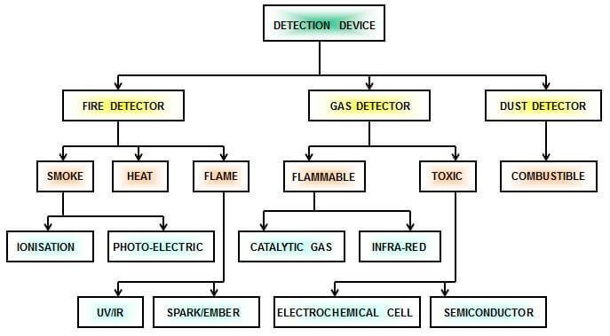

* The ability of a Gas sensor to detect gases depends on the **chemoreceptor** to conduct current. The most commonly used chemoreceptor is Tin Dioxide (SnO2) which is an n-type semiconductor that has free electrons (also called as donor). Normally the atmosphere will contain more oxygen than combustible gases.
* The oxygen particles attract the free electrons present in SnO2 which pushes them to the surface of the SnO2. As there are **no free electrons** available output current will be zero.
* The below gif shown the oxygen molecules (blue colour) attracting the free electrons (black colour) inside the SnO2 and preventing it from having free electrons to conduct current.

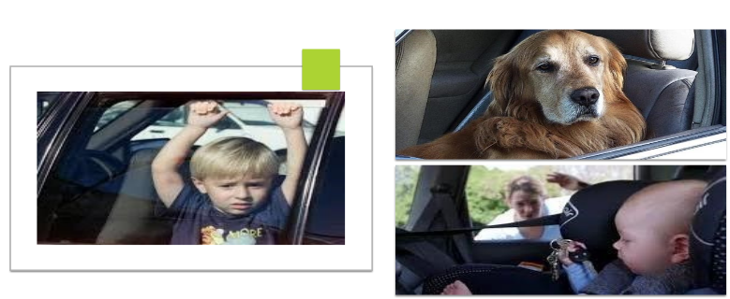

**5. Proposed Innovative Solution and Methodology**

The light intensity when reaches a pyroelectric detector is correlated to the concentration of carbon-dioxide. Co2 variation are detected by measuring the voltage between the two armours of the pyroelectric detector which is proportional to the light intensity. Three main components make up the carbon dioxide sensor:

* A commercial pulsable infrared emitters
* A pyroelectric detector
* A porous silicon

The optical filter consisting of alternating porous silicon layers of different refractive indexes represents the sensing element. The optical filter is projected to selectively allow the propagation of single wavelength 4257nm i.e. Absorption wavelength of the fundamental vibration of carbon dioxide molecule. The optical filter allocated on top of the pyroelectric detector

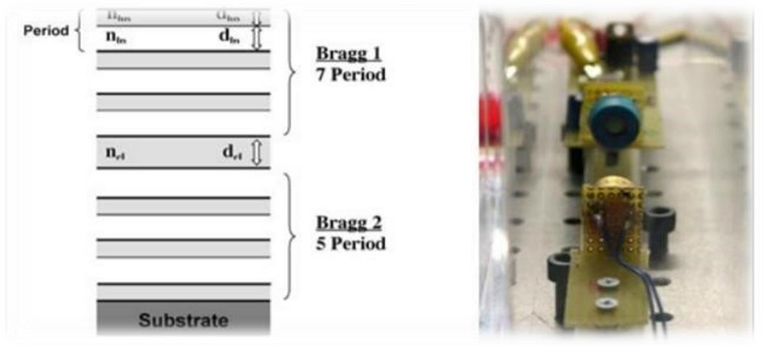

Infrared point sensors measure the [absorption](https://www.enggcyclopedia.com/2011/11/infrared-gas-detectors/) and reflection of IR light when interacting with gasses. As a type of [optical sensor,](https://components101.com/articles/introduction-to-gas-sensors-types-working-and-applications) IR point sensors are comprised of multiple infrared emitters and photodiodes that determine the concentration and type of gas in a given space.

**6.Design and Modelling (Software or Hardware) of the proposed Solution**

* Our technology model helps in the detection of the harmful gases around you, and gives you a signal in order to prevent further accidents.
* This situation is the best way you can protect your infants and pets through the respiratory problems and deaths due to these harmful gases.
* So, this technology enhances the productivity of cars and increase in technology basis for the safety of human beings.

According to problem when certain type of data identified from the gas then when data value is greater than the expected value then using the python script for Arduino, we send a single through the transmitter only 1or 0 if 1 received by receiver then windows will open Here is the signal form:

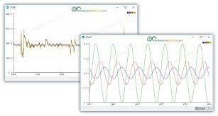

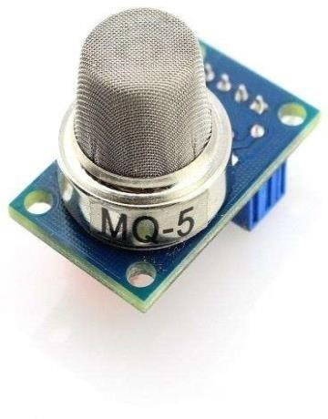 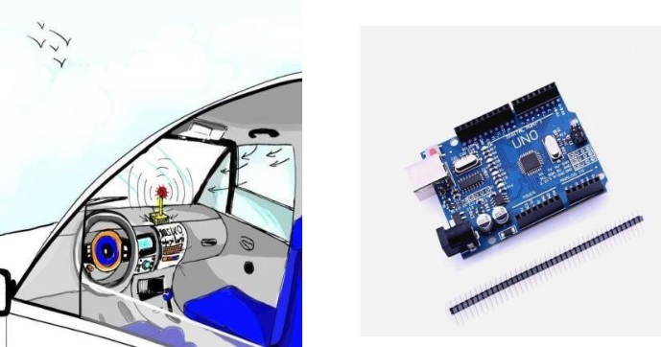

**7. Detailed description of the Prototype or Product (Including block diagrams, working principles, explanation of each and every component, Technology description and demonstration):**

* The purpose of this product is to come up with new idea and technologies that increase the productivity and generate greater output with the same input.

* System to detect the level of Oxygen and Carbon dioxide in the closed cars and open windows when Oxygen levels drop or Carbon dioxide level rise there by preventing accidental death of children or pets locked inside the car.

* MQ-9 gas sensor module has high sensitivity to Carbon Monoxide, Methane and LPG. Sensitive material of MQ-9 gas sensor is SnO2, which with lower conductivity in clean air. It makes detection by cycling high and low temperature, and detects CO when low temperature (heated by 1.5V).

* The sensor’s conductivity is higher along with the gas concentration rising. When temperature rises (heated by 5.0V), it detects Methane, Propane, combustible gas, etc and cleans the other gases as it adsorbed under low temperature.
* MQ-9 usually applied in domestic gas leakage detector, industrial gas detector, portable gas detector, etc.

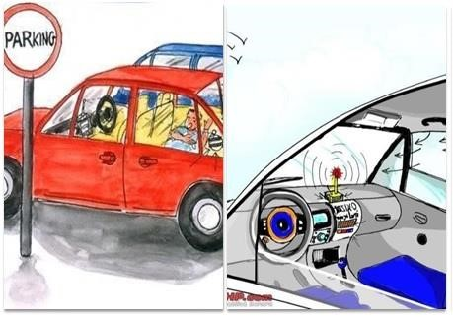

❖ **Features of MQ9 Carbon Monoxide, Methane and LPG Gas Sensor Module: -**

* 1. Suitable for home or factory gas leakage monitoring devices.
  2. Have better sensitivity to Carbon Monoxide, Methane and LPG Gas.
  3. High quality dual-panel design, with power indicator and TTL signal output instructions.
  4. DO switching signal (TTL) output and AO Analog signal output.
  5. TTL output valid signal is low. (When the output low signal is on, it can be directly connected micro-controller or relay module.)
  6. Analog output voltage: the higher concentration, the higher voltage.
  7. Four screw holes, easy positioning.
  8. Long life and stability, quick response and resume.

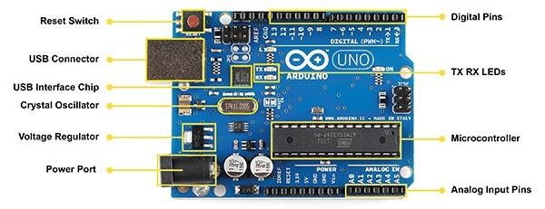

* A microcontroller is embedded inside of a system to control a singular function in a device. It does this by interpreting data it receives from its I/O peripherals using its central processor.
* The temporary information that the microcontroller receives is stored in its data memory, where the processor accesses it and uses instructions stored in its program memory to decipher and apply the incoming data. It then uses its I/O peripherals to communicate and enact the appropriate action.

**WORKINNG OF ARDUINO**

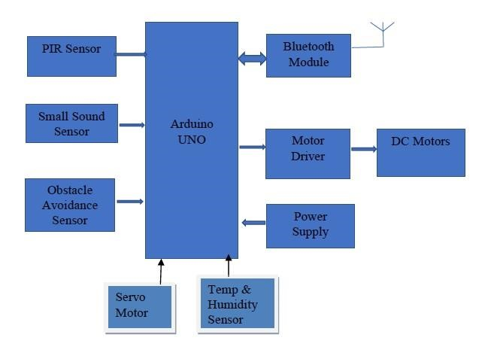

* Arduino UNO is a microcontroller board based on the **ATmega328P**. It has 14 digital input/output pins (of which 6 can be used as PWM outputs), 6 analogy inputs, a 16 MHz ceramic resonator, a USB connection, a power jack, an ICSP header and a reset button.
* It contains everything needed to support the microcontroller; simply connect it to a computer with a USB cable or power it with a AC-to-DC adapter or battery to get started.
* These sensors are connected to an Arduino-UNO and the output is stored in Microcontroller, through the microcontroller the signals from the sensors and the Arduino are transferred and reflected to the fleet management.
* According to the problem when certain type of data identified from the gas then when the data value is greater than expected value then using the transmitter only 1 0r 0. If 1 received by the receiver then windows will close and when the value of the sensors is greater than the optimum Value [indicating there is some problem with the driver] the data is transferred to the servo motors and the windows get opened.

**8.Details of the deployment of product:**

Demand for such type of sensors is very high in the market because in this busy world people do not give priority to small things which costs their life in return.

* Detect the range of CO2.
* Alarm buzzing system.
* Sensor monitoring.
* Moderate cost.
* Thermal conductivity.

**9.Outcomes & Scope for the future extension:**

* Our technology model helps in the detection of the harmful gases around you, and gives you a signal in order to prevent further accidents.
* This situation is the best way you can protect your infants and pets through the respiratory problems and deaths due to these harmful gases.
* So, this technology enhances the productivity of cars and increase in technology basis for the safety of human beings.

**10. References:**

**YouTube link:** [**https://youtu.be/g7c6JKBvf5E**](https://youtu.be/g7c6JKBvf5E)

**Website References** [**https://www.wikipedia.org/**](https://www.wikipedia.org/)

[**https://www.arduino.cc/en/uploads/Main/YUNV04(20150114).pdf**](https://www.arduino.cc/en/uploads/Main/YUNV04(20150114).pdf)

[**https://create.arduino.cc/projecthub/lokeshpurulia/human-detectionrobotics-system-using-arduino-uno-f907cfv**](https://create.arduino.cc/projecthub/lokeshpurulia/human-detection-robotics-system-using-arduino-uno-f907cf)